Machine Learning Flask App Documentation

1. Project Overview
This project is a Machine Learning Flask web application that collects user input from an HTML form, processes it, and predicts output using a pre-trained machine learning model stored as model.pkl.

2. Technologies Used
- Python
- Flask
- HTML, CSS
- NumPy
- Pickle
- Machine Learning model (trained separately)

3. Dataset and Preprocessing
1. Load dataset
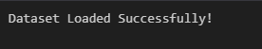
2. Handle missing values
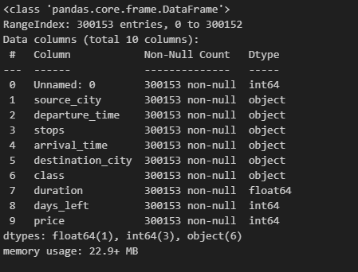
3. Convert categorical values to numeric
4. Split dataset into training and testing sets
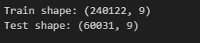
5. Scale numerical features (if needed)

4. Model Training Steps
Below are typical steps used in training the ML model:
- Import required libraries
- Select features and target variable
- Train model using algorithms such as RandomForest, XGBoost, etc.
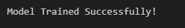
- Evaluate the model using accuracy or other metrics
- Save model using pickle
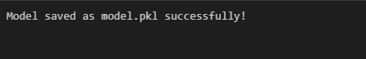

5. Example Model Training Code
import pandas as pd
import numpy as np
from sklearn.model_selection import train_test_split
from sklearn.ensemble import RandomForestRegressor
import pickle

df = pd.read_csv('dataset.csv')
X = df.drop('Price', axis=1)
y = df['Price']

X_train, X_test, y_train, y_test = train_test_split(X, y, test_size=0.2, random_state=42)

model = RandomForestRegressor()
model.fit(X_train, y_train)

pickle.dump(model, open('model.pkl', 'wb'))

6. Flask App Explanation
The Flask app loads model.pkl, receives user input, processes it, and predicts output.
Routes:
- '/' → Loads index.html
- '/predict' → Processes form input and generates prediction

7. index.html Explanation
Contains input fields for 9 numeric values and sends POST request to /predict.
Displays prediction or error message.

8. style.css Explanation
Provides basic styling for the web page including fonts, colors, buttons, and layout.

9. Running the Application
1. Place app.py, model.pkl, templates/, and static/ folders in the same directory.
2. Run command: python app.py
3. Open browser: http://127.0.0.1:5000
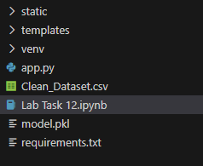

10. Conclusion
This documentation provides complete understanding of the ML model training, saving, and Flask deployment process. The app predicts output based on numeric user inputs using a trained ML model.

